Lucy Tyrteos

1/10/2023

IST-166

NETLAB Assignment #1

**Lab #1: The OSI Model**

Step 5a – Page 12 of 34:

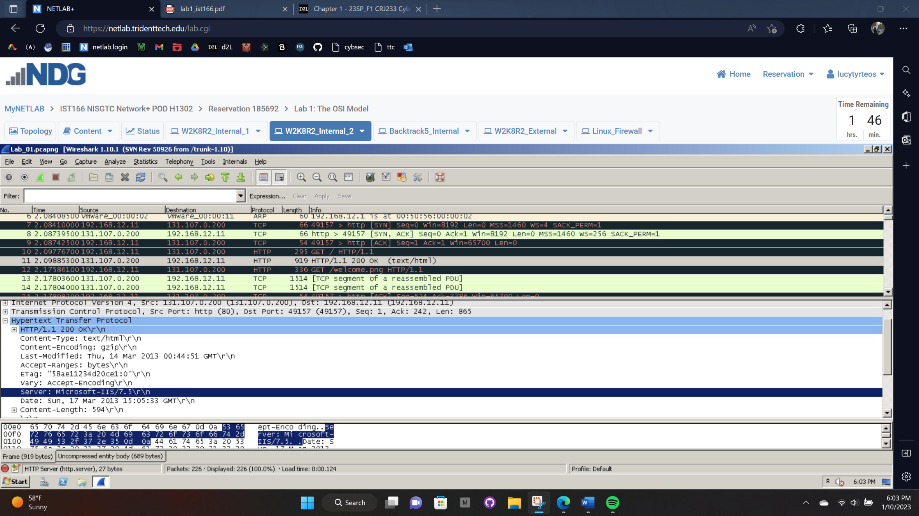

Step 7a – Page 14 of 34:

Step 4a – Page 19 of 34:

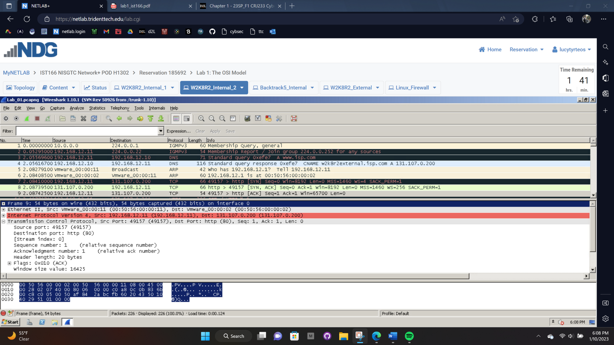

Step 8 - Page 22 of 34:

Step 11 - Page 27 of 34:

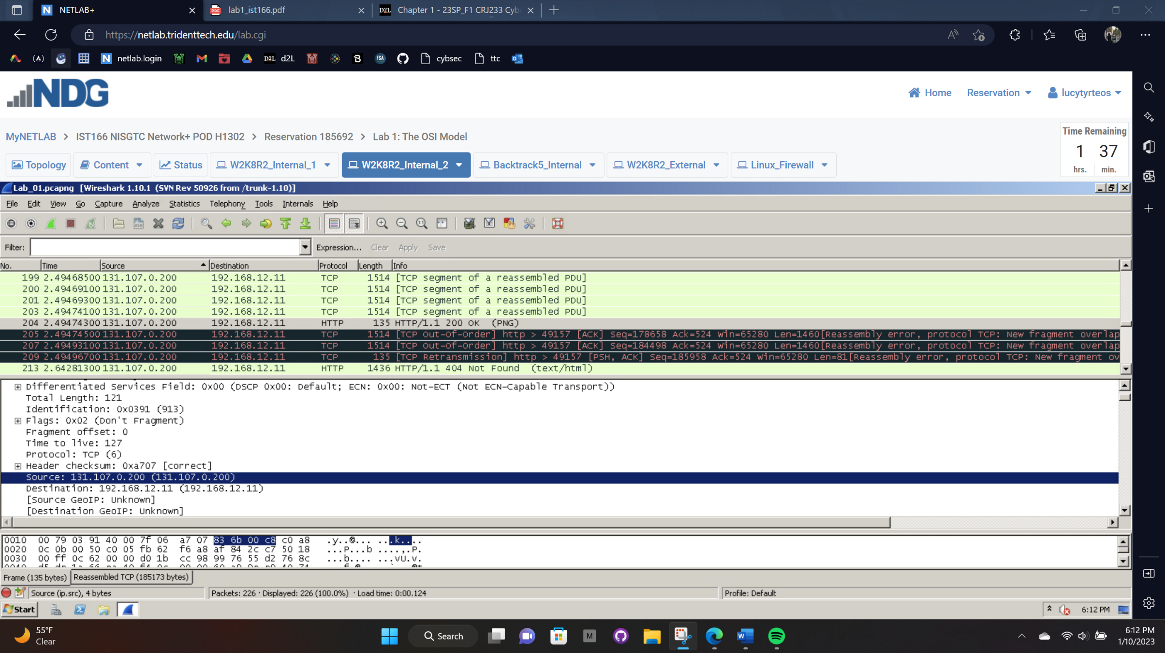

Step 2 - Page 30 of 34:

Step 5 - Page 33 of 34:

